Newsletter № 2

  - HEALTHY EATING AND MOVEMENT FOR A BETTER QUALITY OF LIFE

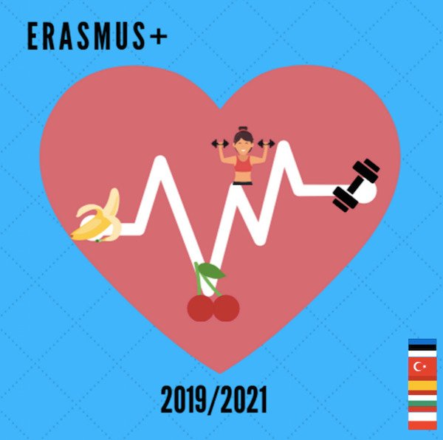
Meeting in in Poland, Wozniki city
June 2022
The title of LTTA is “Sports and physical activities to combat sedentarism and obesity tendencies"

As a result of these activities, we will obtain the following outcomes and outputs:
- participants will practise a set of activities that they can perform in school during breaks or after classes
- improved knowledge of the Polish education system, culture, traditions, cuisine
- materials for the two final brochures (synthesised by the host partner)
- evaluation forms
- certificates of attendance, Europass mobility documents
- photos
The activities combine attending regular classes, visit to school cafeteria, school premises and topic-related workshops, seminars etc. They are organized during the regular working hours, with the exception of cultural activities and events which take place after classes and are meant to strengthen the intercultural, interactional and personal component of projects. Participants are expected to bond and create long-lasting friendships.

Our project on https://twinspace.etwinning.net/93787

All meeting material here: https://sites.google.com/view/healthy-eating-and-movement-fo/c4?authuser=0

