Newsletter № 2

  - HEALTHY EATING AND MOVEMENT FOR A BETTER QUALITY OF LIFE

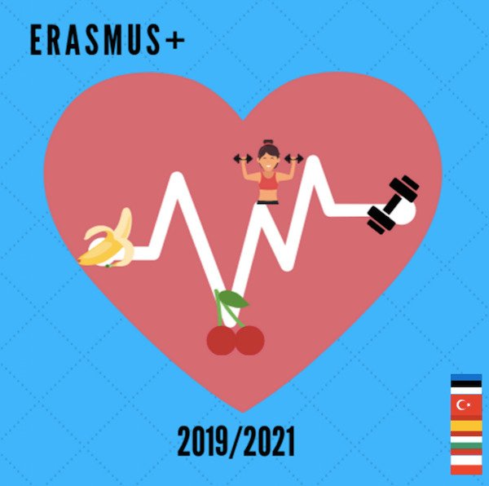
Meeting in Spain, Leon city
April 2022
The title of LTTA is “Obesity – causes and effects on the short, medium and long term”.

As a result of these activities, we will obtain the following outcomes and outputs:
- participants will develop a better understanding of the causes and effects of obesity
- improved knowledge of the Spanish education system, culture, traditions, cuisine
- evaluation report and materials and sample activities produced during C2
- materials for the two final brochures (synthesised by the host partner)
- evaluation forms
- certificates of attendance, Europass mobility documents
- photos
The activities combine attending regular classes, visit to school cafeteria, school premises and topic-related workshops, seminars etc. They are organized during the regular working hours, with the exception of cultural activities and events which take place after classes and are meant to strengthen the intercultural, interactional and personal component of projects. Participants are expected to bond and create long-lasting friendships.

Our project on https://twinspace.etwinning.net/93787

All meeting material here: https://sites.google.com/view/healthy-eating-and-movement-fo/c2?authuser=0

